

Foundations of Programming

Assignment No.: 18
PROBLEM STATEMENT: Write a C program that accepts a string from the user and performs the following string operations: i) Calculate length of string ii) String reversal iii) Equality check of two strings iv) Check palindrome v) Check substring.

OBJECTIVE:

- To understand basic string operations in C.
- To learn how to manipulate strings using loops and functions.
- To perform comparison, reversal, and substring checking.
- To check whether a string is a palindrome.

THEORY:
In C programming, a string is a sequence of characters terminated by a null character ('\0'). Strings are commonly stored in character arrays. Various operations can be performed on strings such as calculating their length, reversing the characters, comparing two strings, checking whether a string is a palindrome, and finding a substring within another string. These operations can be implemented using loops and conditional statements or by using standard library functions from the string.h header file.
PLATFORM: Linux

CODE:
#include <stdio.h>
#include <string.h>
#include <ctype.h>
int main()
{
int len,n=0;
char str1[20],str2[20],rev[20];
printf("Enter a string : ");
scanf("%s", str1);
printf("Enter another string for equality check : ");
scanf("%s", str2);

//Length
len = strlen(str1);
printf("Length of string = %d \n",len);

//Reverse
int l=0;
int r=len-1;
char tem;
strcpy(rev,str1);
while (l<r)
{
tem=rev[l];
rev[l] = rev[r];
rev[r] = tem;
l++;
r--;
}
printf("Reversed string = %s \n", rev);

//Palindrome
l=0;
r=len-1;
while (l<r)
{
if(tolower(str1[l])!=tolower(str1[r]))
n++;
l++;
r--;
}
if(n==0)
printf("The string is Palindrome \n");
else
printf("The string is not Palindrome \n");

//Compare
int cmp = strcmp(str1,str2);
if (cmp>0 || cmp<0)
printf("%s is not equal to %s\n", str1,str2);
else
printf("%s is equal to %s\n", str1,str2);

//Substring
if(strstr(str1,str2)!= NULL)
printf("Substring found in main string");
else
printf("Substring not found");
}

INPUT: A string and another string for comparison and substring checking.
OUTPUT: Displays string length, reversed string, equality result, palindrome result, and substring check result.
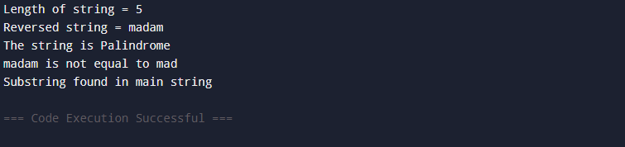

SAMPLE INPUT:

Enter a string: madam
Enter another string for equality check: mad
SAMPLE OUTPUT:
Length of string = 5
Reversed string = madam
The string is a Palindrome
Strings are not equal
Substring found in main string

CONCLUSION: Thus, the C program successfully performs different string operations such as length calculation, reversal, equality check, palindrome check, and substring detection.

FAQs:
- What is a string in C programming?
- Which header file is required for string functions?
- What function is used to find the length of a string?
- What is a palindrome string?
- Which function is used to check a substring in C?

